 | Aranmore Catholic College  Semester 2 Examination, 2015  Question/Answer Booklet

HUMAN BIOLOGICAL SCIENCE
Stage 3A/3B

Student Name _______________________________________
Student’s Teacher ______________________________________

Time allowed for this paper
Reading time before commencing work: ten minutes
Working time for paper: three hours

Materials required/recommended for this paper

To be provided by the supervisor
This Question/Answer Booklet
Multiple-choice Answer Sheet

To be provided by the candidate
Standard items: pens, pencils, eraser, correction fluid, ruler, highlighters
Special items: non-programmable calculators satisfying the conditions set by the Curriculum Council for this course

Important note to candidates
No other items may be taken into the examination room. It is your responsibility to ensure that you do not have any unauthorised notes or other items of a non-personal nature in the examination room. If you have any unauthorised material with you, hand it to the supervisor before reading any further.
Structure of this paper

Section | Number of questions available | Number of questions to be answered | Suggested working time  (minutes) | Marks available | Percentage of exam
Section One:  [Multiple-choice] | 30 | 30 | 40 | 30 | 30
Section Two:  [Short answer] | 15 | 15 | 90 | 100 | 50
Section Three:  [Extended answer] | 3 | 2 | 50 | 40 | 20

Instructions to candidates

1. The rules for the conduct of examinations at Aranmore are detailed in the Examination Information Handbook 2015. Sitting this examination implies that you agree to abide by these rules.

2. Answer the questions according to the following instructions.

Section One: Answer all questions on the separate Multiple-choice Answer Sheet provided. For each question shade the box to indicate your answer. Use only a blue or black pen to shade the boxes. If you make a mistake, place a cross through that square, do not erase or use correction fluid, and shade your new answer. Marks will not be deducted for incorrect answers. No marks will be given if more than one answer is completed for any question.

Sections Two and Three: Write your answers in this Question/Answer Booklet.

3. You must be careful to confine your responses to the specific questions asked and to follow any instructions that are specific to a particular question.

4. Spare pages are included at the end of this booklet. They can be used for planning your responses and/or as additional space if required to continue an answer.
  - Planning: If you use the spare pages for planning, indicate this clearly at the top of the page.
  - Continuing an answer: If you need to use the space to continue an answer, indicate in the original answer space where the answer is continued, i.e. give the page number. Fill in the number of the question(s) that you are continuing to answer at the top of the page.

MULTIPLE CHOICE QUESTIONS

PLEASE ANSWER ON THE MULTIPLE CHOICE ANSWER GRID PROVIDED

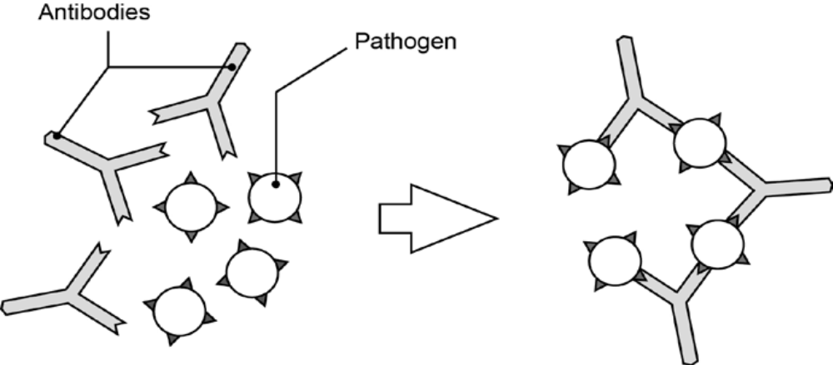
1. The diagram below shows one of the actions of antibodies on pathogens.

What action of antibodies does the diagram represent?

a) Opsonisation.
b) Agglutination.
c) Phagocytosis.
d) Lysis.

2. As a result of disease, a male has suffered damage to his brain. This damage has caused him to be unable to feel full when eating. He eats such large amounts that he is now classified as being obese. The part of his brain most likely to have been damaged is his

a) hypothalamus.
b) cerebral cortex.
c) medulla oblongata.
d) cerebellum.

3. Look at the graph below. Given the information in the graph, describe what would be occurring in the kidney at a blood plasma osmotic pressure of 285 mOsm:

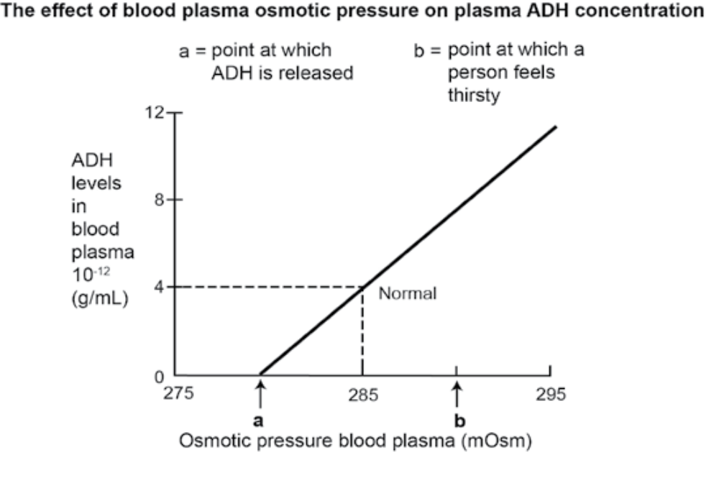

a) Increased permeability in the distil convoluted tubule of the nephron and less movement of water out of the filtrate. The filtrate in turn becoming more dilute.

b) Increased permeability in the distil convoluted tubule of the nephron and greater movement of water out of the filtrate. The filtrate in turn becoming more concentrated.

c) Decreased permeability in the distil convoluted tubule of the nephron and less movement of water out of the filtrate. The filtrate in turn becoming more dilute.

d) Decreased permeability in the distil convoluted tubule of the nephron and less movement of water out of the filtrate. The filtrate in turn becoming more concentrated.
4. The graph below shows the change in blood glucose concentration and the level of a certain hormone after a meal.
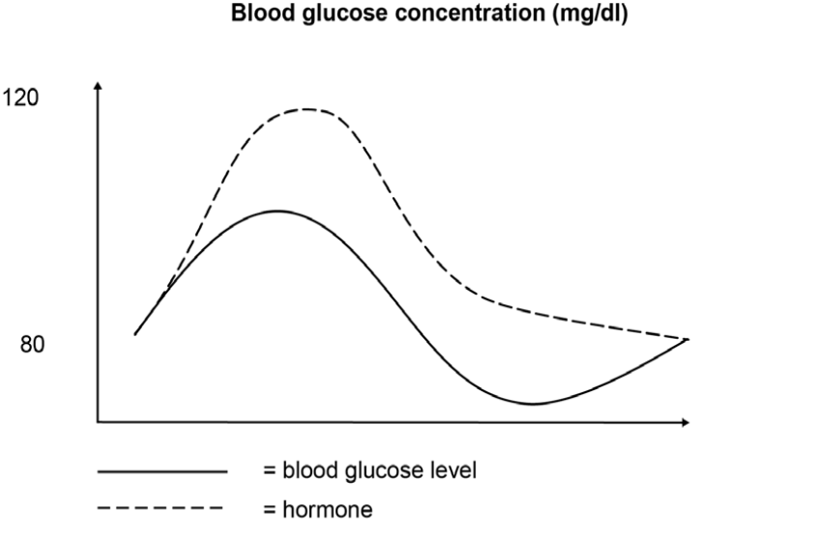
The hormone is:

a) insulin.
b) glucagon.
c) cortisol.
d) glycogen.

5. Scientists link mutations to the process of natural selection very closely.
Mutations:

a) are usually related to the environment in which they appear.
b) are of importance to natural selection only if they can pass from one
generation to the next.
c) usually cause species to become extinct.
d) are usually beneficial to the organism in which they appear.

6. The percentage of adipose tissue in an adult’s body mass can be effected by:

a) Genotype and childhood environmental conditions.
b) Genotype and exposure to Ultra Violet radiation A in childhood.
c) Genotype and exposure to Ultra Violet B radiation in childhood.
d) Genotype and exposure to Ultra Violet B radiation in adulthood.

7. Here are a number of possible genotypes for skin colour.

I. AABBCc
II. AaBbCc
III. AABBCC
IV. AABbCC

Which genotypes will give the same phenotype?
a) I and II.
b) I and IV.
c) II and III.
d) III and IV.

8. A red blood cell has a salt concentration of 0.9%. Haemolysis is where an influx of water into the red blood cell occurs: the cell swells, its membrane ruptures, allowing the escape of their haemoglobin. Which of the following solutions are likely to cause haemolysis?

a) Saline solution of 1.8%
b) Saline solution of 1.0 %
c) Saline solution of 0.9%
d) Saline solution of 0.45%

9. During DNA replication of a certain gene, an extra cytosine was placed into a gene region, throwing off the correct amino acid sequence. This would result in:

a) Deletion mutation with impact on the gene sequence that followed the deletion, known as a “downstream” effect.

b) Insertion mutation with impact on the gene sequence that followed the extra cytosine, known as a “downstream” effect.

c) Base-pair substitution with impact on the gene sequence that followed the deletion, known as a “downstream” effect.

d) Base-pair substitution with no impact on the gene sequence that followed the deletion, known as a “downstream” effect.

10. Some events that take place during the synthesis of a specific protein are listed below.

(A) Messenger RNA attaches to a ribosome.
(B) DNA serves as a template for RNA production.
(C) Transfer RNA bonds to a specific codon.
(D) Amino acids are bonded together.
(E) RNA moves from the nucleus to the cytoplasm.

The correct order of these events is:
a) A -- B – C – D- E
b) B – E – A – C – D
c) B – C – D – E – A
d) C – D – A – E – B

11. Tay-Sachs disease is seen at high frequency in Jewish people from areas of Eastern Europe. One reason for this is that it may give a resistance to:

a) Tuberculosis.
b) Sickle cell anaemia.
c) Malaria.
d) Small pox.
12. The study of homologous structures in mature organisms provides evidence for the evolutionary relationships among certain groups of organisms. Which field of study includes this evidence of evolution?

a) comparative cytology
b) biochemistry
c) geology
d) comparative anatomy

13. Though it does not explain the mechanism of evolution, the study of the embryos and their development reveal that at the embryonic stages there are features that are absent in the adult form. These features are common to a group of organisms. For example, at a particular stage, all the vertebrate embryos possess a single circulation with a two-chambered heart showing no separation into right and left halves. This allows us to see:

a) that some organism may share an evolutionary ancestor.
b) that all organisms have the same type of embryo.
c) that an embryo has the ability to develop into a number of different
vertebrates.
d) That all vertebrates have simple hearts.

14. When mineralocorticoids hormones reach a target cell, they enter the cell and combine with a receptor protein inside the cell. The combined substance enters the nucleus, where it activates genes to produce a protein. Mineralocorticoids are:

a) water soluble amine.
b) water soluble steroid.
c) lipid soluble amine.
d) lipid soluble steroid.

15. Which of the following shows the correct order for the stimulation of the heart in response to exercise?

a) Sympathetic nerves, sino atrial node, cardiac muscle, atrio ventricular node.
b) Parasympathetic nerves, sino atrial node, atrio ventricular node, cardiac muscle.
c) Sympathetic nerves, sino atrial node, atrio ventriclular node, cardiac muscle.
d) Parasympathetic nerves, atrio ventricular node, sino atrial node, cardiac muscle.

16. A red forget-me-not flower is crossed with a white forget-me-not flower. All of the offspring are pink. This shows and example of:

a) Co-dominance.
b) Polygenic inheritance.
c) Dominant and recessive alleles.
d) No definite interpretation can be made.

17. Researchers from the University of Wyoming have developed a way to incorporate spiders' silk-spinning genes into goats, allowing the researchers to harvest the silk protein from the goats’ milk for a variety of applications. For instance, due to its strength and elasticity, spider silk fiber could have several medical uses, such as for making artificial ligaments and tendons, for eye sutures, and for jaw repair. The silk could also have applications in bulletproof vests and improved car airbags. This technology is an example of:

a) point insertion
b) transgenics.
c) genetic transcrition.
d) DNA sequencing.

18. Which of the following organisms are matched best to their cranial capacity?

a) Homo neanderthalensis 450cc.
b) Homo sapien 1500cc.
c) Australopithecus 1000cc.
d) Homo habilis 1500cc.

19. Which of the following statements regarding the founder effect is false?

a) Explains the low frequency of genetic diseases in some island populations of humans.
b) Tends to reduce the impact of genetic drift.
c) Tends to lead to lowered heterozygosity in the newly established population.
d) Is a process that randomly affects allele frequencies.

20. Bone and cartilage are both connective tissue. All connective tissue contains which of the following?

a) A suspensor fluid.
b) A matrix.
c) A hard framework.
d) Synovial fluid.

21. On the 8th of April 2010 news was released of two new human ancestor skeletons being found. The cranial capacity of the two skulls was 420 to 450 cubic centimetres.These skeletons probably date from:

a) 3 million years ago
b) 1.5 million years ago
c) 500,000 years ago
d) 30,000 years ago

22. An infant receiving antibodies through breast milk is an example of which form of immunity?
a) active, artificial
b) active, natural
c) passive, artificial
d) passive, natural

23. Which of the following represents a joint that can only perform flexion or extension?

a) ball and socket
b) hinge joint
c) pivot
d) gliding

24. Alzheimer’s disease is characterised by:

a) damage to the cerebral cortex resulting in impaired memory and thought processes.
b) the large number of medications available for treatment.
c) reduced levels of dopamine.
d) the build up of plaques and tangles in the spinal cord.

Question 25 refers to the diagram below, which illustrates research being conducted into a potential treatment for Alzheimer’s disease.
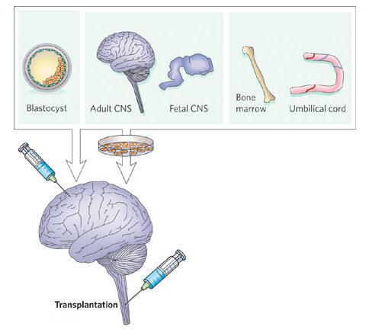
25. This type of biotechnology would be best described as

a) tissue engineering
b) stem cell therapy
c) artificial replacements
d) gene therapy
26. Epigenetics is thought to be due to:

a) Histone modification and DNA methylation.
b) Histone modification and DNA mutation.
c) Structural changes to Histones and DNA.
d) Random genetic drift.

27. Parkinson’s disease is characterised by:

a) damage to the cerebral cortex resulting in impaired memory and thought processes.
b) the large number of medications available for treatment.
c) reduced levels of dopamine.
d) the build up of plaques and tangles in the spinal cord.

28. The following are all steps in the process of electrophoresis

I. DNA is negatively charged so moves towards positive electrodes at far end of gel bed
II. Small DNA pieces move faster than larger ones
III. DNA forms band pattern.
IV. Electric current passed through gel bed
V. DNA pieces placed on gel bed at negative end
The correct order of these steps is:

a) I,II,IV,V, III.
b) III, II, V, I, IV.
c) V, IV, I, II, III.
d) V,I, II,III,IV.

29. Which of the following statements is correct?

a) A sensory neuron starts with a dendrite and ends with a motor end plate.
b) A motor neuron is always part of the afferent peripheral nervous system.
c) A motor neuron often ends at a motor endplate.
d) A motor neuron sends out impulses from its dendrites.
Question 30 refers to the diagram below, which shows three different types of neurons.
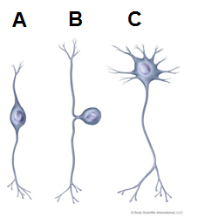
30. Which of the following names structure A, B and C correctly?

 | Structure A | Structure B | Structure C
a) | Bipolar neuron | Sensory neuron | Motor neuron
b) | Inter-neuron | Motor neuron | Multipolar neuron
c) | Motor neuron | Unipolar neuron | Inter-neuron
d) | Inter-neuron | Motor neuron | Sensory neuron

END OF MULTIPLE CHOICE SECTION
Section Two: Short Answer
100 Marks

- Use the diagram below to answer the questions that follow.
(12 marks)
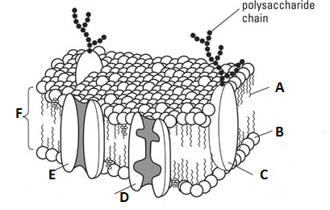

- This is the membrane of a cell in transplanted tissue. When entering the body of the recipient, which of the labelled structures (A, B, C, D, E or F) will the body’s immune system detect as foreign? Give a reason for your answer.
(3 marks)
________________________________________________________________________________________________________________________________________________________________________________________________________________________________________________________________________________________________________________________________

- Of the structures labelled above (A, B, C, D, E or F) which will allow the movement of materials against the concentration gradient? Name the structure and describe the movement of this movement of materials against the concentration gradient by this structure.
(6 marks)
________________________________________________________________________________________________________________________________________________________________________________________________________________________________________________________________________________________________________________________________
_______________________________________________________________________________________________________________________________________________________________________________________________________________________________________________________________________________________________________________________________
_______________________________________________________________________________________________________________________________________________________________________________________________________________________________________________________________________________________________________________________________

- Water can move into and out of the cell due to differences in osmotic potential. Of the structures labelled in the diagram on the previous page (A, B, C, D or E), state which structures will and which structures will not allow the movement of water through the membrane. The name of each structure must be given also.
(3 marks)

_______________________________________________________________________________________________________________________________________________________________________________________________________________________________________________________________________________________________________________________________________________________________________________________________
- The DNA polymerase enzyme used in the PCR method is extracted from the micro-organims Thermus aquaticus. This organism is found living in mineral hot springs and it is able to survive at temperatures of over 90ºC. Why would the DNA polymerase enzyme from this organism be useful in the PCR method?
(3 marks)
________________________________________________________________________________________________________________________________________________________________________________________________________________________________________________________________________________________________________________________________________________________________________________________________________________________________________________________________________________________________________________________________________________________________________________________________

- Use the diagram below to answer the questions that follow.
(13 marks)
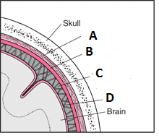

I. This diagram shows the skull and other layers wich hlp portect the brain. The structures labelled A, B, C, and D are grouped together under what name?
___________________________
(1 mark)

II. Complete the table below for the structures labelled in the diagram.

Label | Name of strucuture | Description of structure
A
B
C
D
- marks)

4. (13 marks)

a. Use the data in the table below to draw a suitable graph. There is a spare grid at the back of the test booklet you can use if you need to. If you do use the spare grid, please indicate that you have done so. The table compares the percentage of the population with blood type O from different parts of the world.
(5 marks)
Percentage of Population with Blood type O by Nationality

People | Percentage of Population with O type blood
Indigenous Peruvians ( South America) | 100
Scots(Northern Europe) | 51
Norwegians(Northern Europe) | 39
Kenyans (Africa) | 60
Vietnamese(Asia) | 42



- What percentage of Indigenous Peruvians could donate blood to Kenyans? Give a reason for your answer.
(3 marks)
______________________________________________________________________________________________________________________________________________________________________________________________________________________________________________________________________________________________________________________________________________________________________________________________________________________________________________________________________________

- An A blood group man (homozygous) marries an AB blood group woman. What proportion of their probable offspring could donate blood to their father? Show all working that allowed you to make your prediction.
(5 marks)
________________________________________________________________________________________________________________________________________________________________________________________________________________________________________________________________________________________________________________________________
_______________________________________________________________________________________________________________________________________________________________________________________________________________________________________________________________________________________________________________________________
________________________________________________________________________________________________________________________________________________________________________________________________________________________________________________________________________________________________________________________________

5. (4 marks)
Sunflowers were domesticated fairly recently from a wild sunflower native to North America, and have been under intense artificial selection for increased number of seeds, size of seeds, and sunflower-oil content. The domesticated sunflowers are descended from a small number of wild sunflower plants taken for cultivation. Domestic sunflowers have lower genetic diversity than do the wild populations. Also there is an overall difference in frequencies between the two groups.
Give possible reasons for these differences between wild and domesticated sunflowers? Where appropriate use correct terminology.
________________________________________________________________________________________________________________________________________________________________________________________________________________________________________________________________________________________________________________________________
________________________________________________________________________________________________________________________________________________________________________________________________________________________________________________________________________________________________________________________________
______________________________________________________________________________________________________________________________________________________________________________________________________________________________________________________________________________________________________________________________

6. Protein synthesis involves two main stages, transcription and translation. In the table below outline the key points associated with each stage.

(6 marks)

Description |  |  | Marks
 | Transcription | Translation
Where it occurs in the cell
Main event that occurs during the stage
Type/s of RNA involved in the stage

7. (3 marks)

Nineteen-year-old identical twins, Bob and Bill, are both considered to be tall individuals: Adam is 192 cm and Michael is 188 cm.

An explanation for the different heights of Adam and Michael can be explained using a field of genetics of that has developed in the last few decades. What is this feild and how might it explain the difference?

________________________________________________________________________________________________________________________________________________________________________________________________________________________________________________________________________________________________________________________________________________________________________________________________________________________________________________________________________________________________________________________________________________________________________________________________

SEE NEXT PAGE

8. This question refers to the following diagram, which shows the organisation and divisions of the nervous system.
(3 marks)

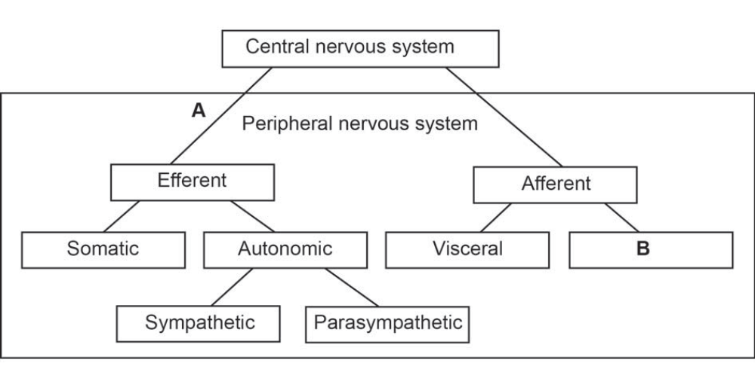

(i) Where is information communicated to from by the division shown as ‘B’ in
the diagram?
(1 mark)
________________________________________________________________________________________________________________________________________________

(ii) A medical condition called hyperhidrosis is caused by an over-activity of neurons
sending impulses to the sweat glands. Symptoms of the condition are normally
seen when a person feels nervous or stressed.
Identify the division of the peripheral nervous system that would be affected by
this condition and the main symptom you would expect to see in sufferers.
(2 marks)

_____________________________________________________________________________________________________________________________________________________________________________________________________________________________________________________________________________________________________________________________________________________________________________________________________

9. Botox is used by some people to make themselves look younger. When Botox is injected into the muscles of the forehead it weakens the action of muscles that cause frowning. Botox contains the toxin Botulinum. Botulinum toxin works to block the release of acetylcholine at the neuromuscular junction. So why are these muscles weakened?
(2 marks)

________________________________________________________________________________________________________________________________________________________________________________________________________________________________________________________________________________________________________________________________________________________________________________________________________________________________________________________________________________________________________________________________________

10. Use the diagram below to answer the questions that follow.
(10 marks)
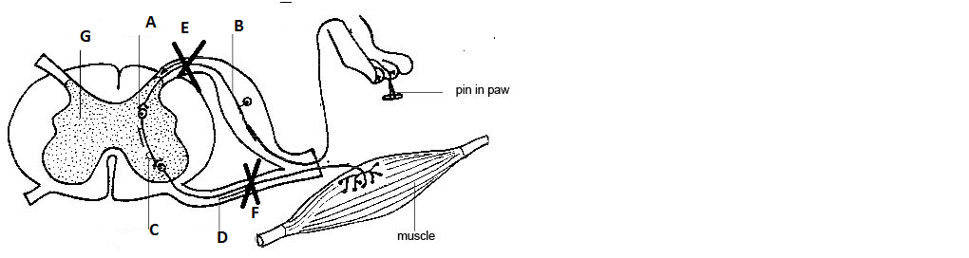

a) Into the table below write the names of the structures labelled on the diagram.

Label | Name of structure
B
C
D
G

(4 Marks)

b) State what would happen if a cut was made at point E.
(1 mark)
____________________________________________________________________________________________________________________________________________________________________________________________________________________________________________________________________

c) State what would happen if a cut was made at point F.
(1 mark)
____________________________________________________________________________________________________________________________________________________________________________________________________________________________________________________________________

d) Name point A and explain how an impulse is transferred here.

(6 marks)
____________________________________________________________________________________________________________________________________________________________________________________________________________________________________________________________________
____________________________________________________________________________________________________________________________________________________________________________________________________________________________________________________________________
___________________________________________________________________________________________________________________________________________________________________________________________________
___________________________________________________________________________________________________________________________________________________________________________________________________________________________________________________________________

11. (9 marks)

Using facial reconstruction software a likeness of an extinct hominin was built up from a skull found in Southern China. The diagram below shows what the face possibly looked like
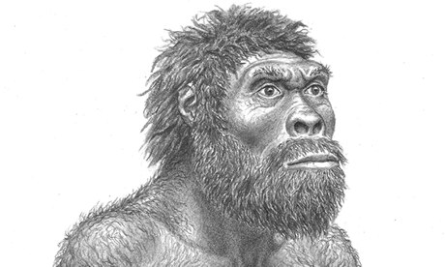

A very similar skull was also found in East Africa.

a) How would this hominin have differed from Australopithecus afarensis in terms of skull structure?

(3 marks)
___________________________________________________________________________________________________________________________________________________________________________________________________
___________________________________________________________________________________________________________________________________________________________________________________________________

b) How would this hominin have differed from australopithecus afarensis in terms of geographical distribution?
(2 marks)
___________________________________________________________________________________________________________________________________________________________________________________________________
__________________________________________________________________________________________________________________________________

c) Give reasons for differences in the ability to manipulate the environment between this hominin in the question and australopithecus afarensis?

(4 marks)
________________________________________________________________________________________________________________________________________________________________________________________________________________________
________________________________________________________________________________________________________________________________________________________________________________________________________________________________________________________________________________________________

12.
(5 marks)
Blood carrying oxygen and Nutrients enters a bone by varies blood vessesls. Describe the pathway the nutrients will take to reach an osteocyte?

________________________________________________________________________________________________________________________________________________________________________________________________________________________________________________________________________________________________________________________________________________________________________________________________________________________________________________________________________________________________________________________________________________________________________________________________________________________________________________________________________________________________________________________________________________________________________________________________________________________________________________________________________________________________

13.
(7 marks)
Here is a diagram of a synovial joint. Label it and then complete the table that follows.

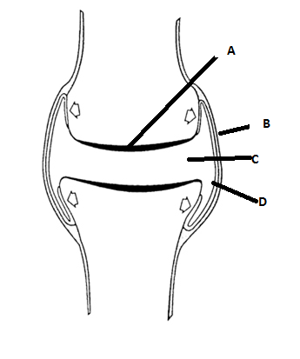
(2 Marks)
II.
Structure | Function
A
B
C
D
(4 marks)

III.
Which tissue above is damaged in Osteoarthritis? Give correct name.

___________________________________________________________________

(1 marks)

14.
(6 marks)
The following table copares two aspects of the endocrine and nervous systems.

Actions occur very quickly following a stumuls | Actions tend to take longer to occur
Action can be over very quickly | Actions tend to be longer lasting

Use your knowledge of the structures and processes involved to explain each of these aspects.

________________________________________________________________________________________________________________________________________________________________________________________________________________________________________________________________________________________________
________________________________________________________________________________________________________________________________________________________________________________________________________________________________________________________________________________________________
_______________________________________________________________________________________________________________________________________________________________________________________________________________________________________________________________________________________________

15.
(4 marks)
Describe the two types of diabetes.

________________________________________________________________________________________________________________________________________________________________________________________________
________________________________________________________________________________________________________________________________________________________________________________________________
________________________________________________________________________________________________________________________________________________________________________________________________________________________________________________________________

End of Section 2

Section 3: Extended Answer Questions. 40 Marks

This section contains THREE (3) questions. Select and attempt any two (2) questions from questions 1, 2 and 3. Write your answers on the lined pages provided. Answers should be written in a blue or black pen.

Responses could, if appropriate, include clearly labelled diagrams with explanatory notes; lists of points with linking sentences; clearly labelled tables and graphs; and annotated flow diagrams with introductory notes.

Suggested working time for this section is 50 minutes.

__________________________________________________________

Question 1 (20 marks)

- It is possible to check to see if a person has a specific gene is present in their genotpype. Name the process used to find the presence of the specific gene and describe the process involved.
(7 marks)

- Researchers are hoping to start human clinical trials for Tay-Sachs disease using gene therapy. They hope to achieve this by using modified viruses that are infused into cerebrospinal fluid.

Describe the process of how the viruses would be genetically engineered and then how it could lead to a treatment for Tay-Sachs.
(13 marks)

Question 2 (20 marks)

- Allele frequency can be changed by random genetic drift and genetic
bottle necks.

- What is meant by allele frequency?
(1 marks)
- Give a brief description of random genetic drift and state what type of populations it can have the greatest impact on?
(2 marks)
- Name 3 sources of evidence Charles Darwin had available to him to support his theory of Natural Selection.
(3 marks)
- Natural selection can also alter allele frequency. Briefly describe natural selection.
- marks)

- Sickle Cell Anaemia is a blood disorder. Briefly describe this disorder, its means of inheritance and possible reasons for its prevalence in areas such as West Africa.
(10 marks)

Question 3 (20 marks)

a. The development of powerful microscopes in the early 1950s allowed Hugh Huxley in 1953 to introduce the Sliding filament model for muscle contraction. Using suitable diagrams, explain this model
(15 marks)
b. Study of this muscle tissue revealed that the muscle cells were multinucleate and contained many mitochondria. State a reason for the large number of mitochondria.
(1 mark)
c. The tough, flexible band of fibrous connective tissue that connects muscles to bones can be found at the ends of muscles. How do we classify these ends and what do we call this band of connective tissue?
(4 marks)

End of questions.

Question number: __________________

_____________________________________________________________________________________________________________________________________________________________________________________________________________________________________________________________________
_______________________________________________________________________________________
_____________________________________________________________________________________________________________________________________________________________________________________________________________________________________________________________________
_______________________________________________________________________________________
_____________________________________________________________________________________________________________________________________________________________________________________________________________________________________________________________________
_______________________________________________________________________________________
_____________________________________________________________________________________________________________________________________________________________________________________________________________________________________________________________________
_______________________________________________________________________________________
_____________________________________________________________________________________________________________________________________________________________________________________________________________________________________________________________________
_______________________________________________________________________________________
_____________________________________________________________________________________________________________________________________________________________________________________________________________________________________________________________________
_______________________________________________________________________________________
_____________________________________________________________________________________________________________________________________________________________________________________________________________________________________________________________________
_______________________________________________________________________________________
_____________________________________________________________________________________________________________________________________________________________________________________________________________________________________________________________________
_______________________________________________________________________________________
_____________________________________________________________________________________________________________________________________________________________________________________________________________________________________________________________________
Question number: __________________

_______________________________________________________________________________________
_____________________________________________________________________________________________________________________________________________________________________________________________________________________________________________________________________
_______________________________________________________________________________________
_____________________________________________________________________________________________________________________________________________________________________________________________________________________________________________________________________
_______________________________________________________________________________________
_____________________________________________________________________________________________________________________________________________________________________________________________________________________________________________________________________
_______________________________________________________________________________________
_____________________________________________________________________________________________________________________________________________________________________________________________________________________________________________________________________
_______________________________________________________________________________________
_____________________________________________________________________________________________________________________________________________________________________________________________________________________________________________________________________
_______________________________________________________________________________________
_____________________________________________________________________________________________________________________________________________________________________________________________________________________________________________________________________
_______________________________________________________________________________________
_____________________________________________________________________________________________________________________________________________________________________________________________________________________________________________________________________
_______________________________________________________________________________________
_____________________________________________________________________________________________________________________________________________________________________________________________________________________________________________________________________
_______________________________________________________________________________________
_____________________________________________________________________________________________________________________________________________________________________________________________________________________________________________________________________
Question number: __________________
_______________________________________________________________________________________
_____________________________________________________________________________________________________________________________________________________________________________________________________________________________________________________________________
_______________________________________________________________________________________
_____________________________________________________________________________________________________________________________________________________________________________________________________________________________________________________________________
_______________________________________________________________________________________
_____________________________________________________________________________________________________________________________________________________________________________________________________________________________________________________________________
_______________________________________________________________________________________
_____________________________________________________________________________________________________________________________________________________________________________________________________________________________________________________________________
_______________________________________________________________________________________
_____________________________________________________________________________________________________________________________________________________________________________________________________________________________________________________________________
_______________________________________________________________________________________
_____________________________________________________________________________________________________________________________________________________________________________________________________________________________________________________________________
_______________________________________________________________________________________
_____________________________________________________________________________________________________________________________________________________________________________________________________________________________________________________________________
_______________________________________________________________________________________
_____________________________________________________________________________________________________________________________________________________________________________________________________________________________________________________________________
_______________________________________________________________________________________
_____________________________________________________________________________________________________________________________________________________________________________________________________________________________________________________________________
_______________________________________________________________________________________
Question number: __________________
_____________________________________________________________________________________________________________________________________________________________________________________________________________________________________________________________________
_______________________________________________________________________________________
_____________________________________________________________________________________________________________________________________________________________________________________________________________________________________________________________________
_______________________________________________________________________________________
_____________________________________________________________________________________________________________________________________________________________________________________________________________________________________________________________________
_______________________________________________________________________________________
_____________________________________________________________________________________________________________________________________________________________________________________________________________________________________________________________________
_______________________________________________________________________________________
_____________________________________________________________________________________________________________________________________________________________________________________________________________________________________________________________________
_______________________________________________________________________________________
_____________________________________________________________________________________________________________________________________________________________________________________________________________________________________________________________________
_______________________________________________________________________________________
_____________________________________________________________________________________________________________________________________________________________________________________________________________________________________________________________________
_______________________________________________________________________________________
_____________________________________________________________________________________________________________________________________________________________________________________________________________________________________________________________________
_______________________________________________________________________________________
_____________________________________________________________________________________________________________________________________________________________________________________________________________________________________________________________________
_______________________________________________________________________________________

Question number: __________________
_____________________________________________________________________________________________________________________________________________________________________________________________________________________________________________________________________
_______________________________________________________________________________________
_____________________________________________________________________________________________________________________________________________________________________________________________________________________________________________________________________
_______________________________________________________________________________________
_____________________________________________________________________________________________________________________________________________________________________________________________________________________________________________________________________
_______________________________________________________________________________________
_____________________________________________________________________________________________________________________________________________________________________________________________________________________________________________________________________
_______________________________________________________________________________________
_____________________________________________________________________________________________________________________________________________________________________________________________________________________________________________________________________
_______________________________________________________________________________________
_____________________________________________________________________________________________________________________________________________________________________________________________________________________________________________________________________
_______________________________________________________________________________________
_____________________________________________________________________________________________________________________________________________________________________________________________________________________________________________________________________
_______________________________________________________________________________________
_____________________________________________________________________________________________________________________________________________________________________________________________________________________________________________________________________
_______________________________________________________________________________________
_____________________________________________________________________________________________________________________________________________________________________________________________________________________________________________________________________
_______________________________________________________________________________________

Additional working space.



